Q1. Genetic Algorithm [Marks 6, 4+2, 15 min]
You are given the target string: "HELLO". You are given the initial population below: -
RGYXP, HQLLA, XELLO, HZKLO
A. Use a Genetic Algorithm to evolve the population of strings to match the target. Describe the steps of the GA process, including:
- Initial population generation (given).
- Fitness function (Evaluate as the number of characters matching in the correct position)
- Selection (tournament selection select any two pairs and making sure good solutions go to next generation)
- Crossover(Crossover point at 2)
- Mutation (Fixed: The gene at index 3 in a selected chromosome is randomly replaced with any letter from a-z)
- Termination condition
Note: Next population consists of 2 parents from the initial population and 2 offspring.
B. Show how the GA evolves toward the solution after the first generations and also calculate the fitness value for the evolved generation. Explain

Answer:

1. Initial Population Generation:
Example:
- RGYXP
- HQLLA
- XELLO
- HZKLO
2. Fitness Function:
Evaluate how close each individual string is to the target.
Fitness can be defined as the number of characters matching in the correct position.
Example for target "HELLO":
- RGYXP → fitness = 0
- HQLLA → fitness = 2 (H and L)
- XELLO → fitness = 4 (E, L, L, O)
- HZKLO → fitness = 3 (H, L, O)

3. Selection:
Choose parents based on fitness (e.g., roulette wheel or tournament selection).
Fitter individuals have a higher chance to be selected. Example: XELLO and HZKLO.

4. Crossover:
Combine parts of two parents to produce offspring.
Example crossover between XELLO and HZKLO:
- Crossover point at 2 → XE from parent 1 + KLO from parent 2 → XEKLO
- Or HZ from parent 2 + LLO from parent 1 → HZLLO

5. Mutation:
Randomly change a character with a low probability to introduce diversity.
Example mutation: XEKLO → HELLO (if X mutates to H, and K to L)

CLO2: To identify and relate methods of search and practically apply the corresponding techniques.

Q2. Adversarial Search [Marks 4, 15 min]
A. A game is played between max and min. Draw a tree considering Max as a first player and the branching factor is 2. Given terminal values below, show backed-up values, the best decision available at the root, and branches that will get pruned (explain why they are getting pruned if any).
4, 5, 2, 3, 7, 6, 11, 2, -14, -7, -21, -24, 9, 10, 11, 12.
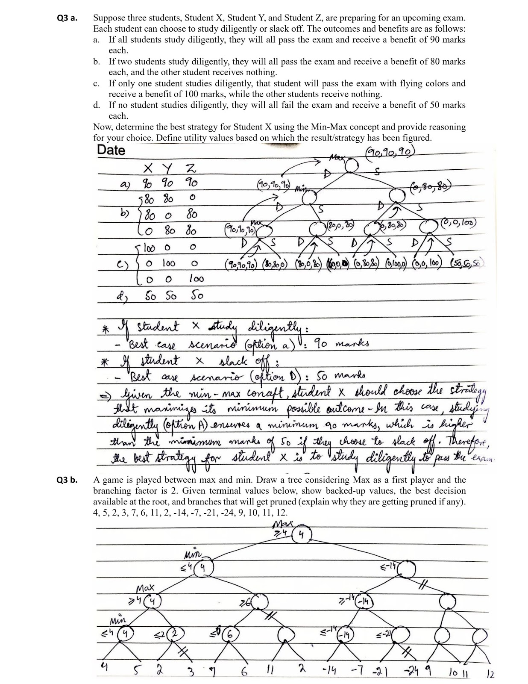

CLO2: To identify and relate search methods and practically apply the corresponding techniques.

Q3. Constraint Satisfaction Problems [Marks 8, 4+4, 30 min]
Consider a Constraint Satisfaction Problem defined by α, β, θ ∈ {a,b,c} and
constraints β=θ and α>β (lexical: 'c' > 'b' > 'a').
A. Demonstrate a step-by-step dry run of the Arc Consistency algorithm. Start by showing the initial queue of arcs, and for each step of the algorithm, clearly indicate the following.
- The arc is being processed.
- Any values removed from the domains of the variables after enforcing arc consistency.
- The updated domains after processing the arc.
- Any new arcs added to the queue as a result of domain reduction.
What are the final domains of variables α, β, and θ after the Arc Consistency Algorithm has completed its execution?
α, β,θ∈{a,b,c} and constraints α>β (lexical: 'c' > 'b' > 'a') and β=θ
α = {a,b,c} Agenda Arcs Marks
β = {a,b,c} 1 α>β α>β
θ = {a,b,c} 2 β<α β<α
α>β 3 β=θ β=θ
β=θ 4 θ=β θ=β

1 α>β β<α
α = {a,b,c} α = {b,c} β=θ M1
β = {a,b,c} β = {a,b,c} θ=β

2 β<α β=θ
β = {a,b,c} β = {a,b} θ=β M1
θ = {a,b,c} θ = {a,b,c} α>β New arc added in queue/Agenda

3 β=θ θ=β M1 for updating Agenda
β = {a,b} No change α>β
θ = {a,b,c}

4 θ=β α>β
θ = {a,b,c} θ = {a,b} β=θ New arc added in queue/Agenda M1
β = {a,b} β = {a,b}

5 α>β β=θ
α = {b,c} No change
β = {a,b}

6 β=θ empty α = {b,c} A1 for correct
β = {a,b} No change β = {a,b} Answer.
θ = {a,b} θ = {a,b} Total = 5

B. You are scheduling 5 classes on Mondays, Wednesdays, and Fridays, with 3 professors where each professor can teach only one class at a time, and some classes have overlapping time slots.
Time | 9:00 - 10:00 | 9:30 - 10:30 | 10:00 - 11:00 | 11:00 - 12:00 | 11:30 - 12:30
Classes | C1 | C2 | C3 | C4 | C5

Professor | Can teach | Other constraint
Ahmed (A) | C2, C4, & C5
Babar (B) | C1, C2, & C4
Chishti (C) | C1, C3, & C5 | Refuses to teach 2 classes in a row
Draw the Constraint Graph for this problem.
Note: All classes are of exactly one hour duration.

Nodes C1, C2, C3, C4, C5

Edges C1-C2 M1
time overlap C2-C3 M1
C4-C5 M1
Chisti’s constraint is not a time-Overlap constraint hence can not be represented
as an “Edge”, it is more like a sequential constraint. Total = 3
Allow dotted line representation for Chisti’s Constraint
or just a suitable comment If ignored/not shown -1

